**ASSIGNMENT-2**

**Archana Narayanan(an2adv), Ruchir Shah(rvs4xt)**

**BUILD A PEDOMETER**

**QUESTIONS:**

1. **Choose the Sensor**

The sensor chosen is the SparkFun 9DoF Sensor Stick which utilizes the LSM9DS1 motion sensing chip. It contains a 3-axis accelerometer, 3 axis magnetometer and a 3 axis gyroscope. Inorder to build a pedometer, our logic was to make use of the accelerometer value since the accelerometer values along the x,y,z axes will increase with walking in a specific direction. Hence this sensor was the best fit to record the number of steps.

1. **Choose the location to place the sensor**

We imagine the sensor to be a separate wearable device on the chest, below the sternum, something that can be attached to clothes or the body. We utilize the acceleration along the Y direction when placed in this manner, and therefore this location produces accurate results comparatively.

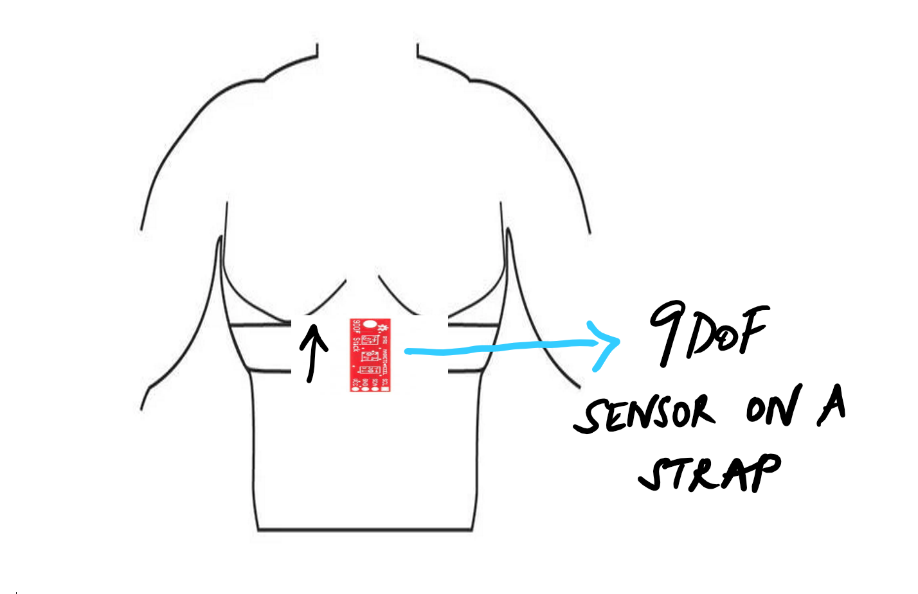

1. **Observe the signal**

With the location of our sensors facing the direction of our walk, with the sensor stick placed above the sternum, we observed the values of the accelerometer along the x,y and z axis. We also observed the axes values from the gyroscope. From these values, it made sense to exploit the y axis feature from the accelerometer as it produced corresponding results to the steps walked in all the directions. From the distribution of values, it was evident that preprocessing was necessary to clearly see the results such as setting a threshold to detect the steps and accommodating a small delay before the values are compared with the threshold to record the action as a step taken to move forward or backward.

1. **Choose the feature**

From the different values observed along the 3 axes of the accelerometer and the gyroscope, we will use the acceleration along the Y-direction to detect the steps taken. This is because the change in values observed from the Y axis of the accelerometer corresponds to the steps taken while walking ,more accurately than the other features. The snapshot below depicts the increase in Y axis value of the accelerometer for 5 steps forward with 100 % accuracy.

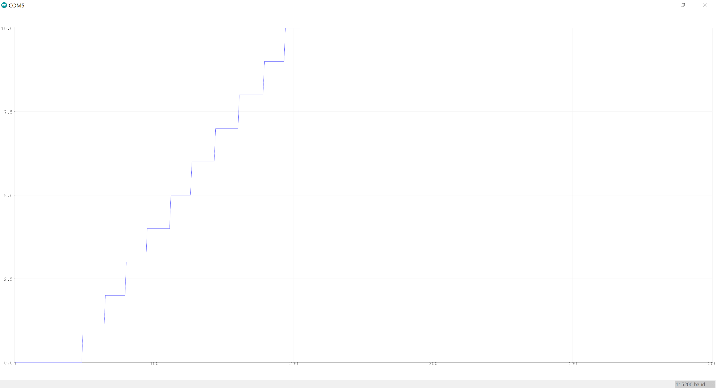

1. **Implement the Step Counting Algorithm**

The system records the acceleration along the Y-direction in our setup every 200 milliseconds. This value is compared with the threshold of 1.115. The selection of the threshold is based on multiple trials recording the acceleration along Y value and it was evident that each step taken results in a value greater than 1.115. If the value recorded is greater than the threshold then the algorithm increases the number of steps taken by 1. The algorithm is implemented in Embedded C in Arduino IDE. The results are output on the serial plotter or monitor. The baud rate is set to 115200 to output the results.

**SETUP CONNECTION:**

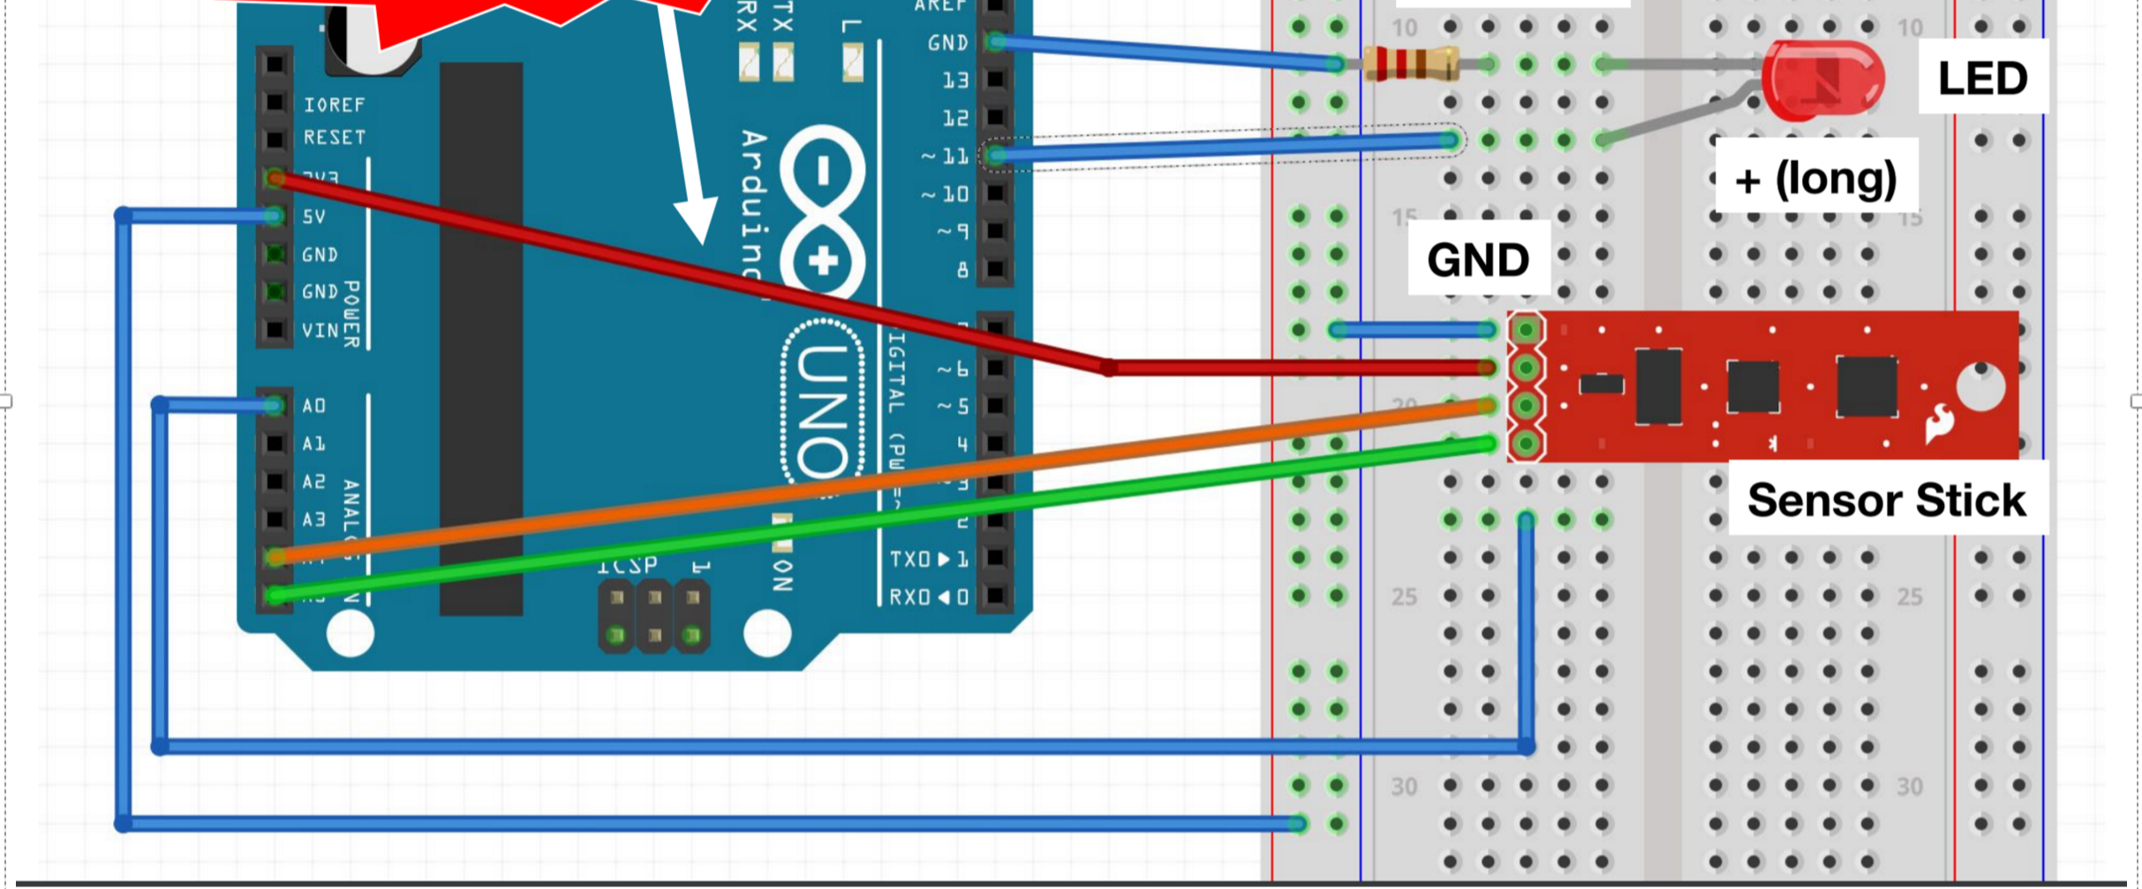

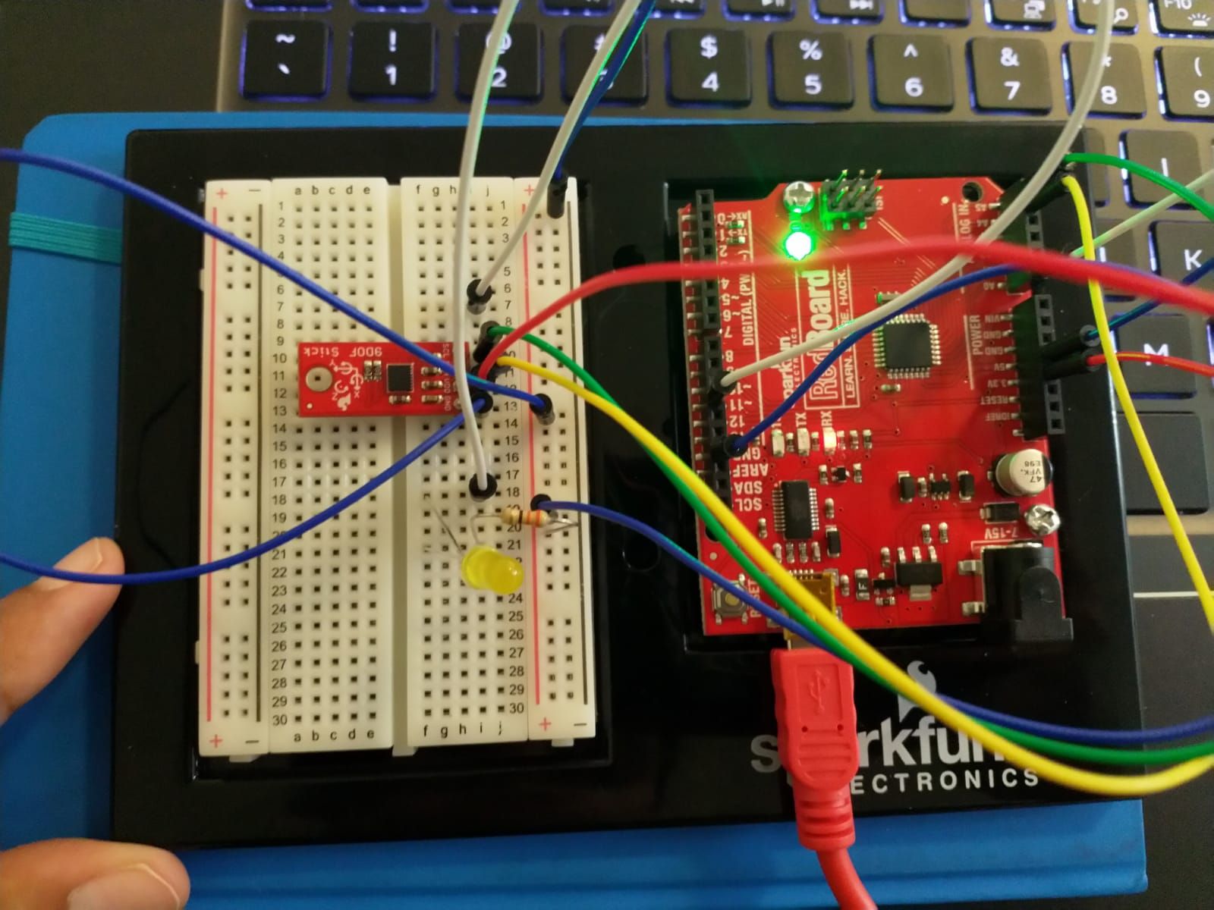

1. **Test if it correctly measures the steps**

**Team Member 1 accuracy:**

* Number of steps taken = 45
* Number of Steps recorded by the Program = 43
* Error = 2
* Accuracy_One = 42/45 * 100 = 95.6%.

I repeated the process for 5 trials and the accuracy remained consistent between 93-97%.

**Team Member 2 accuracy:**

* Number of steps taken =
* Number of Steps recorded by the Program =
* Error =
* Accuracy_Two =

Average Accuracy = ( Accuracy_One + Accuracy_Two ) / 2

**AVERAGE ACCURACY =**

**RESULTS:**



**BONUS PROBLEM:**

**AUTOMATIC DETECTION of Walking vs Jumping along with the VELOCITY AND TIME taken for the jumps**

Our program also detects the number of jumps and automatically identifies walking vs jumping and displays it on the serial monitor. Furthermore, it detects the velocity of the jump when the jump is detected.

The 90DoF sensor is used which utilizes the LSM9DS1 motion sensing chip. It contains a 3 axis accelerometer. We utilize the change in acceleration along y-axis and z-axis to differentiate between a jump and walking. We imagine the location of the sensor to be the same as before, i.e. to be a separate wearable device on the chest, below the sternum, something that can be attached to clothes or the body.

We observed the values of acceleration along all 3 axis and determined a threshold with upper bound and lower bound value for the system to detect a walk versus a step. After observing the distribution of values along all 3 axes for jumping and walking, we concluded that a threshold range of 1.115 <= ay <= 1.165 is necessary for acceleration along y axis inorder to detect walking and count the number of steps. A threshold range of 1.65 <= ay <= 3 with az > 0 is the condition set to detect jumping since the acceleration along z -axis is positive when a jump occurs.

*Here ay = Acceleration along y-axis and az= acceleration along z -axis.*

Additionally, we calculate the time taken for the jump using which the velocity is computed. The velocity is given by the product of acceleration and the total time taken for the jump to reach its highest peak. It displays the time for which the system is in the air and the velocity/ speed of the jump.

*The algorithm details are explained below:*

The sensor reads the acceleration along y and z axes. The values recorded are compared with the threshold. If the sensor readings satisfy the threshold condition for walking or jumping, the counter is incremented accordingly to keep a tab on the number of steps or jumps. At the same instant we start a timer if a jump condition is satisfied. At the end of the jump, the timer stops and the elapsed time gives us information about the time for which the system was in the air. Using this, the velocity is computed and displayed along with the number of steps or jumps made. The algorithm is implemented in Embedded C in Arduino IDE. The results are output on the serial plotter or monitor. The baud rate is set to 115200 to output the results. This works with an accuracy of 88- 92%.

**ACCURACY:**

**Team Member 1 Accuracy:**

* Number of Steps taken = 30
* Number of Steps Detected = 27
* Number of Jumps Made = 6
* Number of Jumps Detected = 5
* Velocity displayed for all jumps
* Combined Error = 4
* Accuracy_One = 89 %

I repeated the process for multiple trials and the accuracy remained consistent between 88 -92%.

**Team Member 2 Accuracy:**

* Number of Steps taken =
* Number of Steps Detected =
* Number of Jumps Made =
* Number of Jumps Detected =
* Velocity displayed for all jumps
* Combined Error =
* Accuracy_One =

**Average Accuracy = ( Accuracy_One + Accuracy_Two ) / 2**

**AVERAGE ACCURACY =**

**RESULTS:**

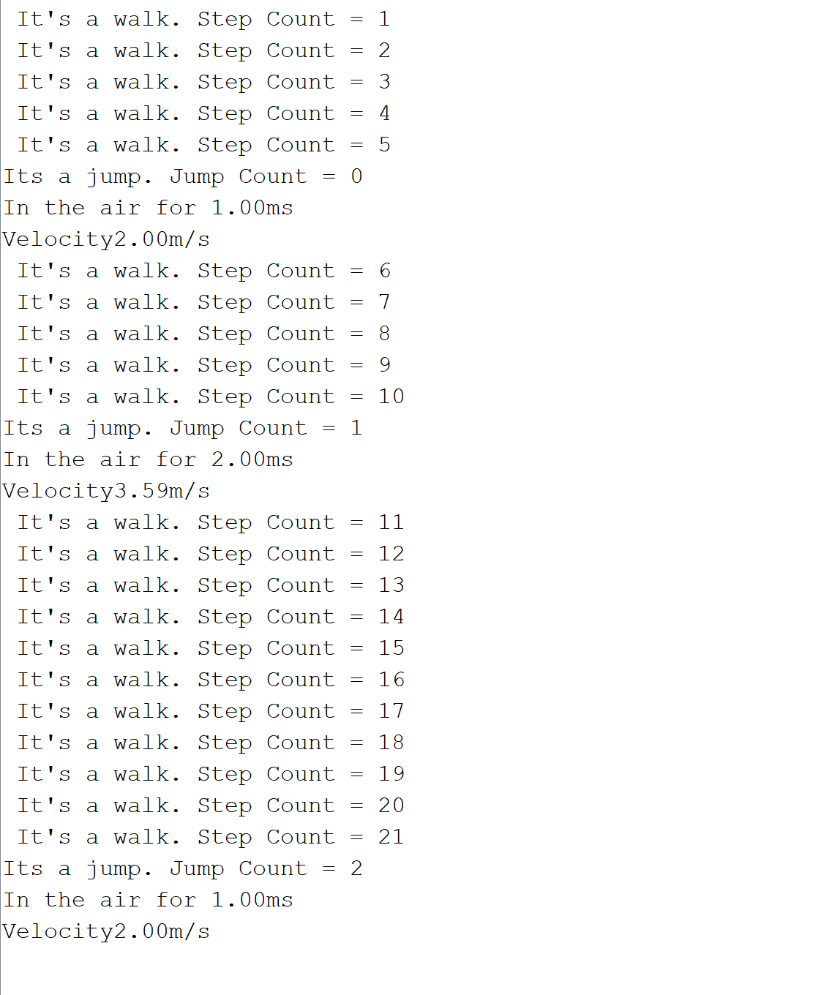

**CONCLUSION:**

**The implemented system consists of a standalone pedometer that detects the number of steps with an accuracy of 93-97% consistently. Additionally, we also built an integrated system that detects walking versus jumping along with velocity and time calculation for the jumps. The results for this system consists of an accuracy between 88-92 % throughout. We utilize the y-axis and z-axis values of the accelerometers from the 90DoF sensor to set the values of threshold for detection.**

**WORK DISTRIBUTION:**

As a team, most of our work was split equally or done together after discussion. When designing or testing the algorithms, we worked individually to write the code and discussed the results observed. We are submitting the work that produced the most accurate results after various improvisations from error corrections.

Ruchir Shah - 50 %

* Step Counting Algorithm
* Skipping Algorithm
* Push Up detection Algorithm
* Report

Archana Narayanan - 50 %

* Step Counting Algorithm
* Skipping Algorithm
* Integration and velocity detection
* Report

The videos and .ino files are attached with submission along with this report.